**Mean Absolute Error (MAE):**

- Formula :

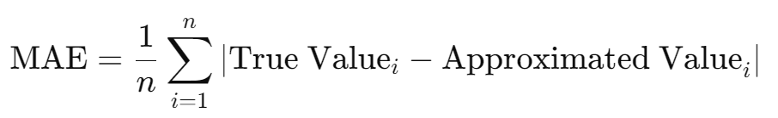

\(\text{MAE} = \frac{1}{n} \sum_{i=1}^{n} | \text{True Value}_i - \text{Approximated Value}_i |\)

- Significance: MAE measures the average magnitude of the errors in a set of predictions, without considering their direction. It provides a straightforward measure of how far the approximated values deviate from the true values on average. Since it takes the absolute value of the differences, it treats all errors equally, regardless of their direction.

**Mean Squared Error (MSE):**

- Formula :

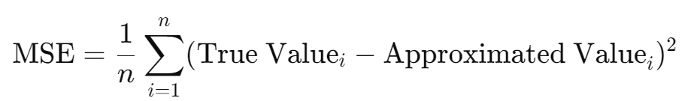

\(\text{MSE} = \frac{1}{n} \sum_{i=1}^{n} (\text{True Value}_i - \text{Approximated Value}_i)^2\)

- Significance: MSE measures the average of the squared differences between the true and approximated values. It heavily penalizes larger errors because the differences are squared. This makes it useful for highlighting significant deviations and is especially relevant when large errors are particularly undesirable.

**Root Mean Squared Error (RMSE):**

- Formula:

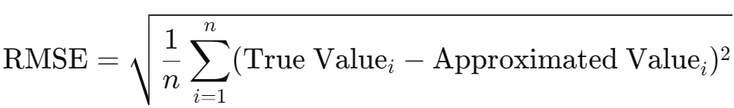

\(\text{RMSE} = \sqrt{\frac{1}{n} \sum_{i=1}^{n} (\text{True Value}_i -\text{Approximated Value}_i)^2}\)

- Significance: RMSE is the square root of MSE and provides error values in the same units as the original data, making it easier to interpret. It combines the advantages of MSE (sensitivity to large errors) with a more interpretable scale. RMSE is commonly used in many fields to measure the accuracy of models.

**R-squared (Coefficient of Determination):**

- Formula:

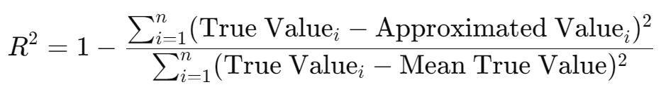

\(R^2 = 1 - \frac{\sum_{i=1}^{n} (\text{True Value}_i - \text{Approximated Value}_i)^2}{\sum_{i=1}^{n} (\text{True Value}_i - \text{Mean True Value})^2}\)

- Significance: R-squared measures the proportion of the variance in the true values that is predictable from the approximated values. It provides an indication of the goodness of fit of a model. An \(R^2\) value close to 1 indicates that a large proportion of the variance in the true values is explained by the approximated values, while an \(R^2\) value close to 0 indicates that the model fails to explain the variance.

These metrics collectively provide a comprehensive understanding of the errors in approximations, highlighting both average performance and potential worst-case scenarios.

3*3 Edge detection Filter is used in our work to illustrate the convolution. Several images and the Convolution output is shown below along with the Error metrics:

Edge Detection Filter: [[-1,-1,-1], [-1,8,-1], [-1,-1,-1]]

Errors are calculated for the Input Image and BFP normalized Input Image, Output Image and BFP Normalized Output Image

Here, all the input image are considered of size 256*256 and output image is of size 254*254

1. House

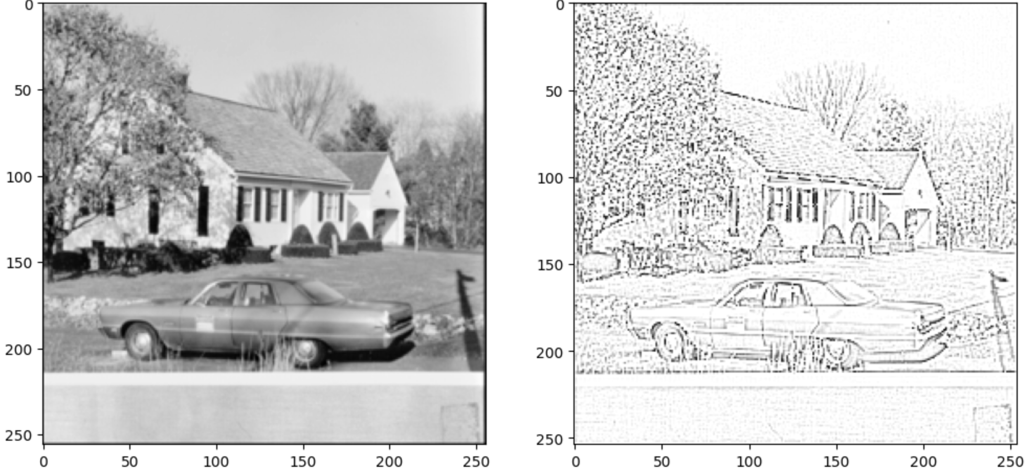 

Input Image Output Image

**Error Analysis of Input**

Mean Absolute Error (MAE): 0.10513333976268768

Mean Squared Error (MSE): 0.01605466658656951

Root Mean Squared Error (RMSE): 0.12670701080275515

R-squared (R^2): 0.9999926415561815

**Error Analysis of Output**

Mean Absolute Error (MAE): 0.14078320562839508

Mean Squared Error (MSE): 0.0966794341802597

Root Mean Squared Error (RMSE): 0.3109331727027893

R-squared (R^2): 0.9999708506784373

1. Fishing Boat

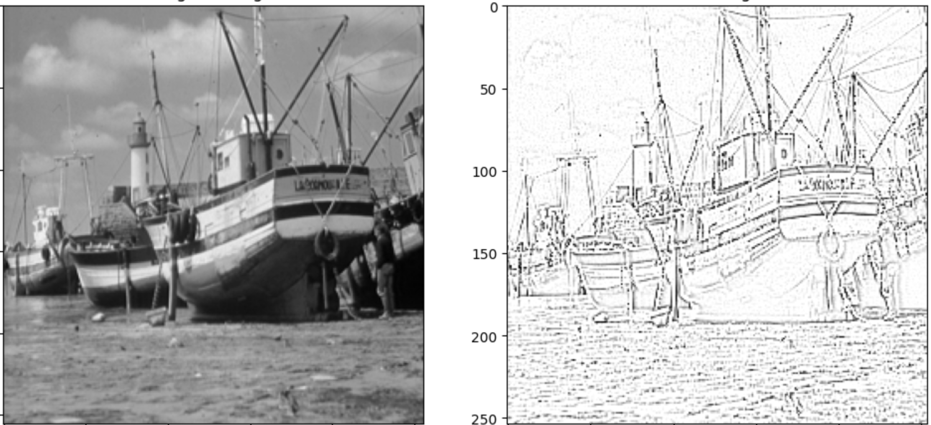 

Input Image Output Image

**Error Analysis of Input**

Mean Absolute Error (MAE): 0.11123742163181305

Mean Squared Error (MSE): 0.01632462460838724

Root Mean Squared Error (RMSE): 0.12776785436246177

R-squared (R^2): 0.9999921739741313

**Error Analysis of Output**

Mean Absolute Error (MAE): 0.13165481388568878

Mean Squared Error (MSE): 0.08579657971858978

Root Mean Squared Error (RMSE): 0.29291054606437683

R-squared (R^2): 0.999973939236952

1. Peppers

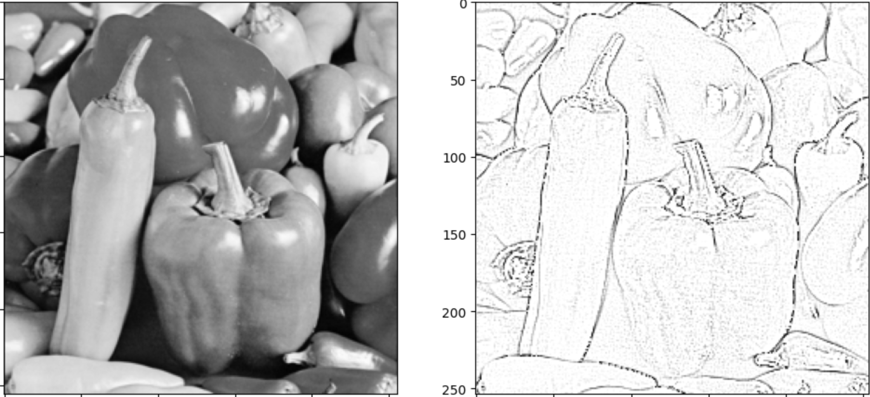 

Input Image Output Image

**Error Analysis of Input**

Mean Absolute Error (MAE): 0.12267960608005524

Mean Squared Error (MSE): 0.019740747680771165

Root Mean Squared Error (RMSE): 0.1405017710947843

R-squared (R^2): 0.9999930582627037

**Error Analysis of Output**

Mean Absolute Error (MAE): 0.09243478626012802

Mean Squared Error (MSE): 0.05502191558480263

Root Mean Squared Error (RMSE): 0.23456750810146332

R-squared (R^2): 0.9999656368418073

1. Mandrill

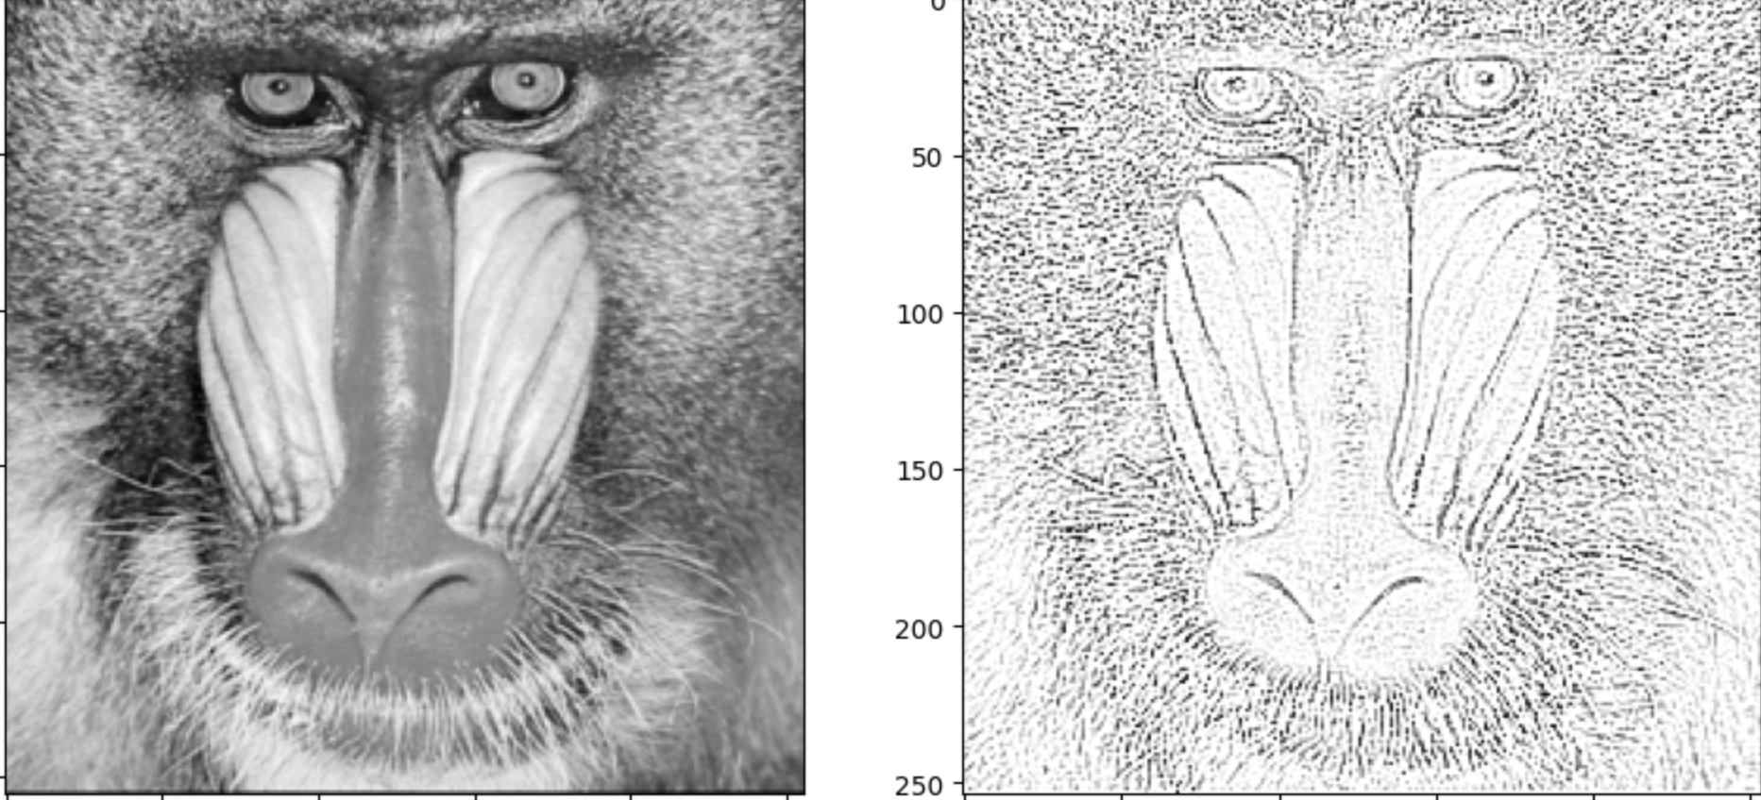 

Input Image Output Image

**Error Analysis of Input**

Mean Absolute Error (MAE): 0.13299687206745148

Mean Squared Error (MSE): 0.023244392228662036

Root Mean Squared Error (RMSE): 0.15246111710420476

R-squared (R^2): 0.9999839489748691

**Error Analysis of Output**

Mean Absolute Error (MAE): 0.20850640535354614

Mean Squared Error (MSE): 0.1445768028497696

Root Mean Squared Error (RMSE): 0.380232572555542

R-squared (R^2): 0.9999729558476247

1. Walter Cronkite

 

Input Image Output Image

**Error Analysis of Input**

Mean Absolute Error (MAE): 0.11667026579380035

Mean Squared Error (MSE): 0.018445784560753964

Root Mean Squared Error (RMSE): 0.13581525893931787

R-squared (R^2): 0.9999937291595002

**Error Analysis of Output**

Mean Absolute Error (MAE): 0.06711529195308685

Mean Squared Error (MSE): 0.04198281839489937

Root Mean Squared Error (RMSE): 0.20489709079265594

R-squared (R^2): 0.9998407936946023

1. Pentagon

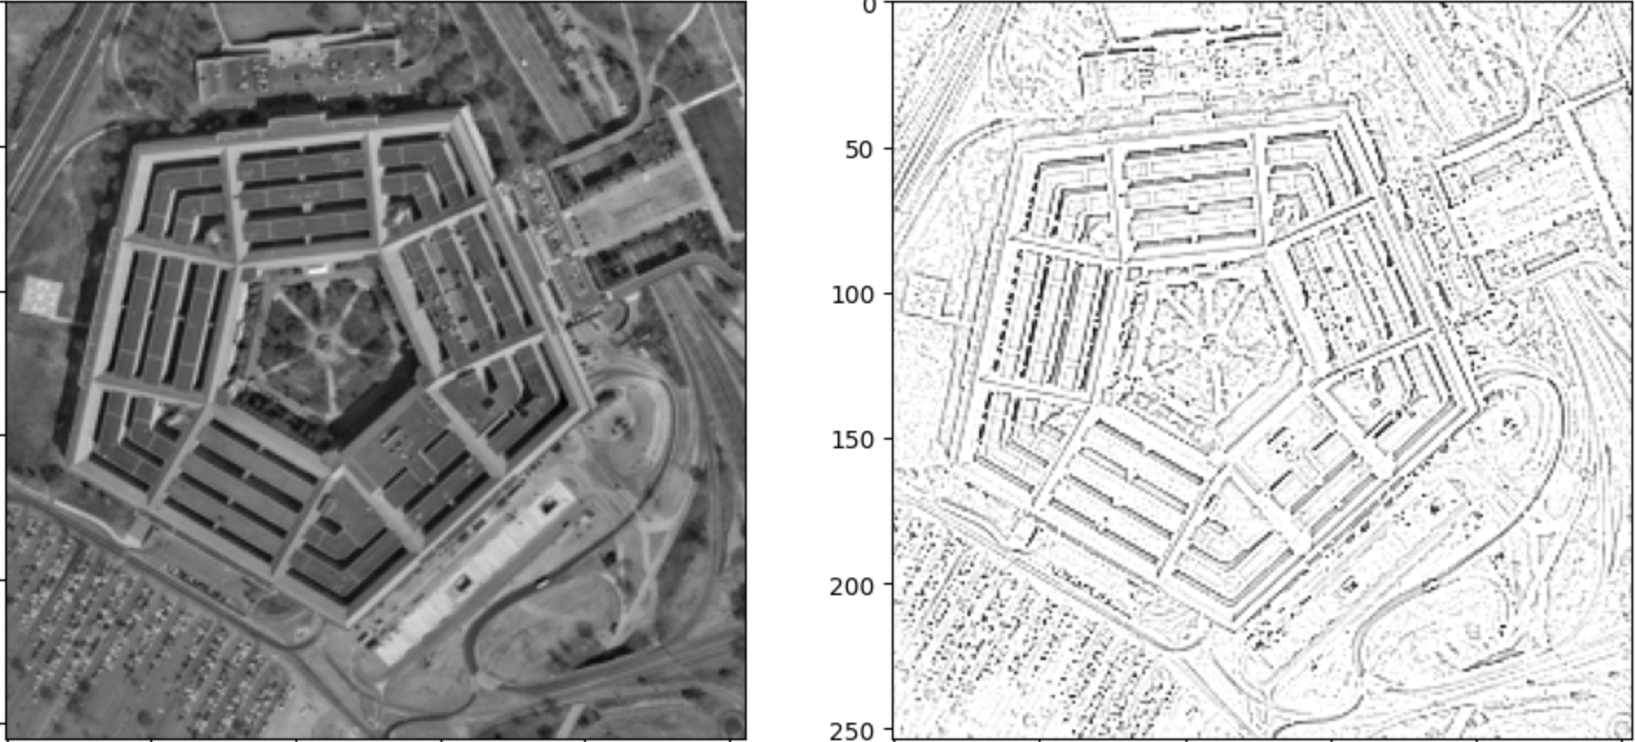 

Input Image Output Image

**Error Analysis of Input**

Mean Absolute Error (MAE): 0.11357682943344116

Mean Squared Error (MSE): 0.018675181723665446

Root Mean Squared Error (RMSE): 0.13665716857766902

R-squared (R^2): 0.999966512295279

**Error Analysis of Output**

Mean Absolute Error (MAE): 0.18963752686977386

Mean Squared Error (MSE): 0.13567352294921875

Root Mean Squared Error (RMSE): 0.3683388829231262

R-squared (R^2): 0.999937063017569

AREA REPORT GENERATED BY CADENCE GENUS

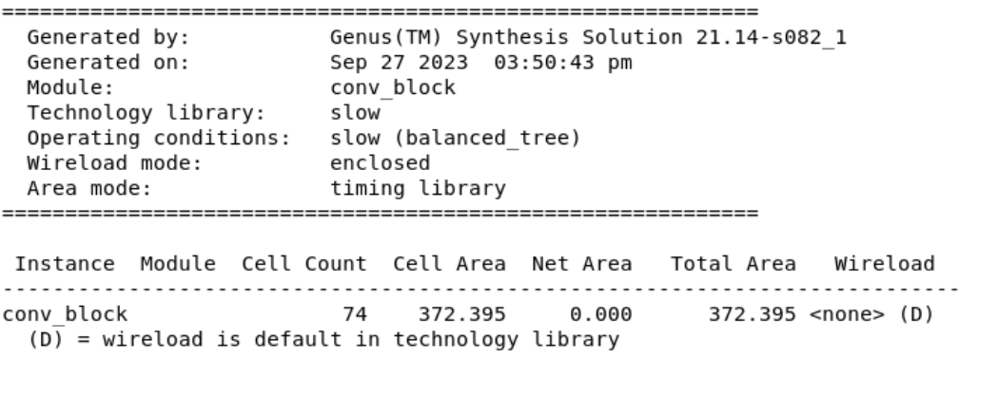

POWER REPORT GENERATED BY CADENCE GENUS

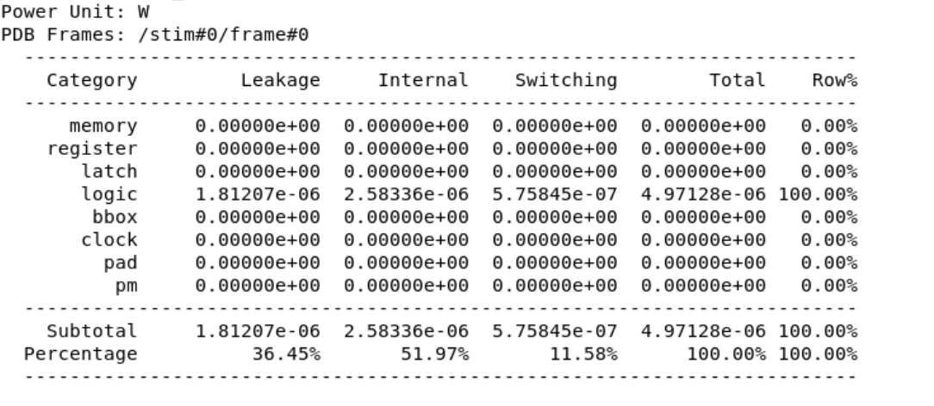

LAYOUT GENERATED BY CADENCE – INNOVUS

